Given Dataset of college students as a text file (name,subject,grade,marks)

**Dataset screen shot**

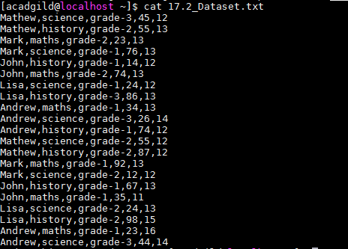

**Problem Statement 1:**

1. **Read the text file, and create a tupled rdd.**

**Solution :**

Val baseRDD = sc.textFile(“/home/acadgild/17.2_Dataset.txt”).

val baseRDD1 = baseRDD.map(x=>(x.split(",")(0),x.split(",")(1),x.split(",")(2),x.split(",")(3).toInt,x.split(",")(4).toInt))

baseRDD1.foreach(println)

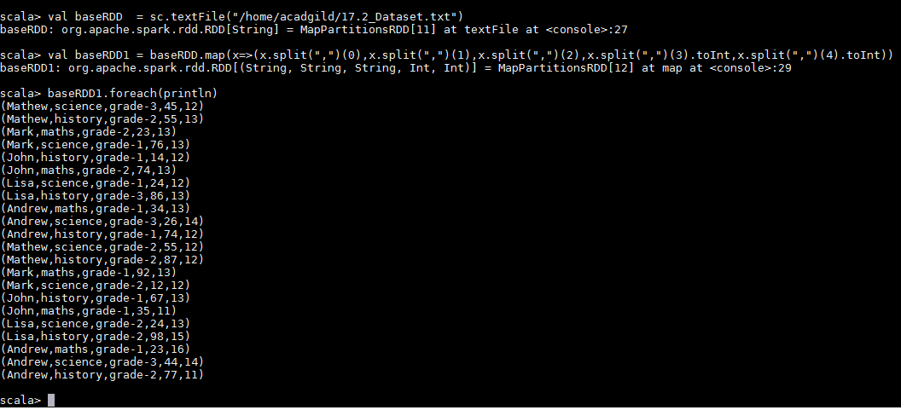

1. **Find the count of total number of rows present.**

**baseRDD.count()**

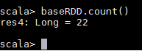

1. **What is the distinct number of subjects present in the entire school**

val baseRDD = sc.textFile(“/home/acadgild/17.2_Dataset.txt”)

val baseRDD1 = baseRDD.map(x=>(x.split(",")(1),1))

val ReduceRDD = baseRDD1.reduceByKey((x,y)=>(x+y))

ReduceRDD.foreach(println)

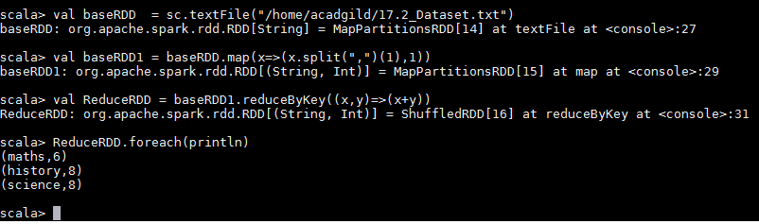

4. **What is the count of the number of students in the school, whose name is Mathew and**

**marks is 55**

val baseRDD = sc.textFile(“/home/acadgild/17.2_Dataset.txt”).map(x=>(x.split(",")(0), x.split(",")(3).toInt,1))

val RDDfilter= baseRDD .filter(x=>x._1 ==’Mathew” &&x._2==55)

val ReduceRDD = RDDfilter.reduceByKey((x,y)=>(x+y)).foreach(println)



**Problem Statement 2:**

1. **What is the count of students per grade in the school?**

val baseRDD = sc.textFile(“/home/acadgild/17.2_Dataset.txt”).map(x=>(x.split(",")(2), x.split(",")(3).toInt,1)).reduceByKey((x,y)=>x+y).foreach(println)

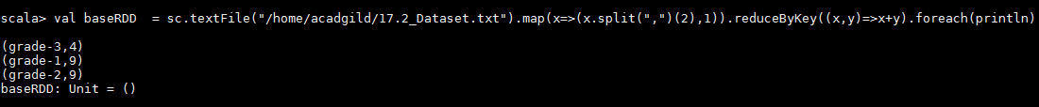

2**. Find the average of each student (Note - Mathew is grade-1, is different from Mathew in**

**some other grade!)**

val baseRDD = sc.textFile("/home/acadgild/17.2_Dataset.txt").map(x=>(x.split(",")(0), x.split(",")(3).toInt))

val baseRDD1 = baseRDD.mapValues(x=>(x,1))

val RDDreduce = baseRDD1.reduceByKey((x,y)=>(x._1 + y._1, x._2 + y._2))

val StudAvg = RDDreduce.mapValues{case(sum,count)=>(1.0*sum)/count}

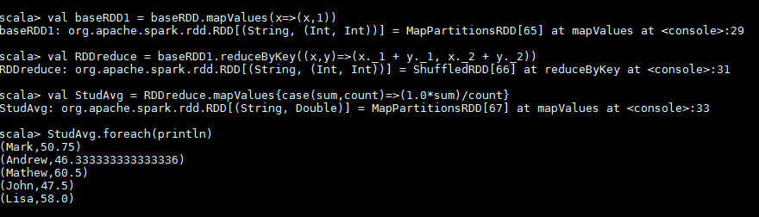

1. **What is the average score of students in each subject across all grades?**

val baseRDD = sc.textFile("/home/acadgild/17.2_Dataset.txt").map(x=>(x.split(",")(1), x.split(",")(3).toInt))

val baseRDD1 = baseRDD.mapValues(x=>(x,1))

val RDDreduce = baseRDD1.reduceByKey((x,y)=>(x._1 + y._1, x._2 + y._2))

val SuddAvg = RDDreduce.mapValues{case(sum,count)=>(1.0*sum)/count}

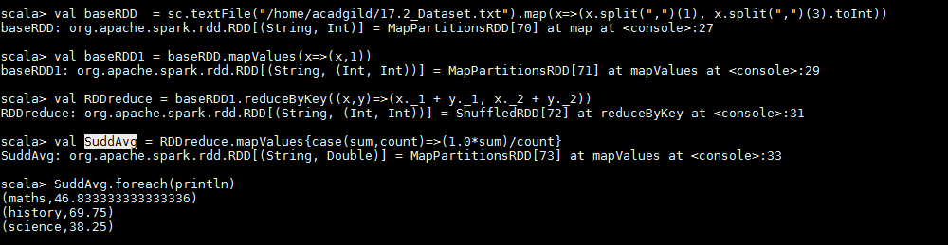

1. **What is the average score of students in each subject per grade?**

val baseRDD = sc.textFile("/home/acadgild/17.2_Dataset.txt").map(x=>((x.split(",")(1), x.split(",")(2)), x.split(",")(3).toInt))

val baseRDD1 = baseRDD.mapValues(x=>(x,1))

val RDDreduce = baseRDD1.reduceByKey((x,y)=>(x._1 + y._1, x._2 + y._2))

val Avg_grade = RDDreduce.mapValues{case(sum,count)=>(1.0*sum)/count}

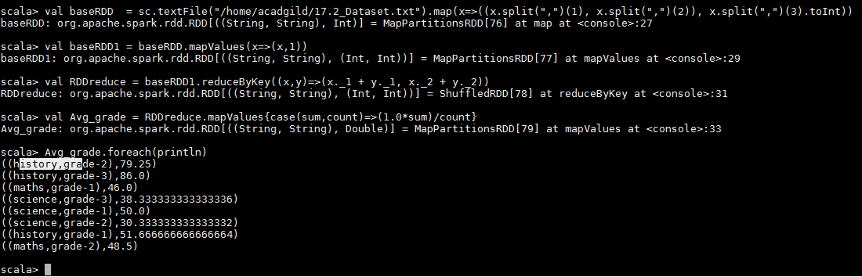

1. **For all students in grade-2, how many have average score greater than 50?**

val baseRDD = sc.textFile("/home/acadgild/17.2_Dataset.txt").map(x=>((x.split(",")(0), x.split(",")(2)), x.split(",")(3).toInt))

val baseRDD1 = baseRDD.mapValues(x=>(x,1))

val RDDreduce = baseRDD1.reduceByKey((x,y)=>(x._1 + y._1, x._2 + y._2))

val RDDAvg = RDDreduce.mapValues{case(sum,count)=>(1.0*sum)/count}

val Rddfiltermap = RDDAvg.filter(x=>x._1._2 == “grade-2” && x._2> 50).count()

val Rddfiltermap = RDDAvg.filter(x=>x._1._2 == “grade-2” && x._2> 50).foreach(println))

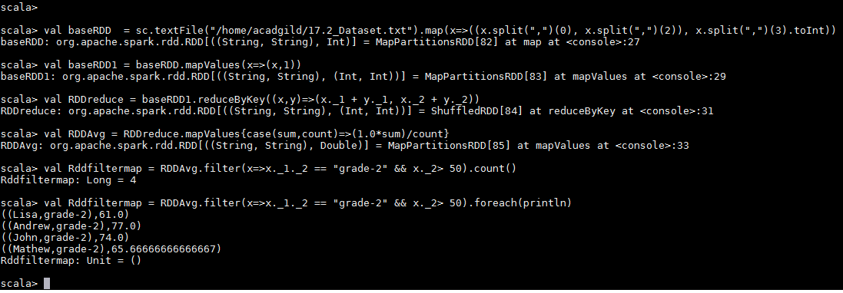

**Problem Statement 3:**

Are there any students in the college that satisfy the below criteria :

1. Average score per student_name across all grades is same as average score per

student_name per grade

Hint - Use Intersection Property.

val baseRDD = sc.textFile("/home/acadgild/17.2_Dataset.txt").map(x=>(x.split(",")(0), x.split(",")(3).toInt))

val stuAvg = baseRDD.mapValues(x=>(x,1)).foreach(println)

val RDDreduce = stuAvg.reduceByKey((x,y)=>(x._1 + y._1, x._2 + y._2))

val avg_std = RDDreduce.mapValues{case(sum,count)=>(1.0*sum)/count}

